Segmented bridge, Florida Keys
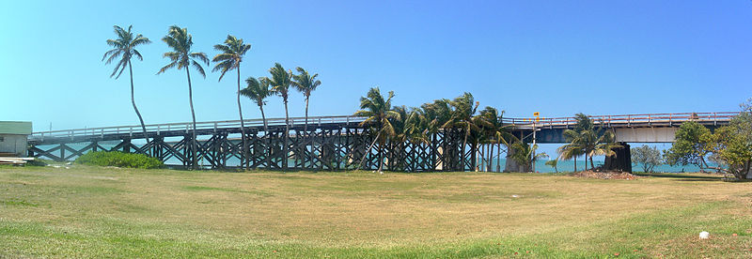
http://en.wikipedia.org/wiki/File:Pigeon_Key_FL_HD_pano02.jpg

Suspension bridge, Golden Gate Bridge. San Francisco
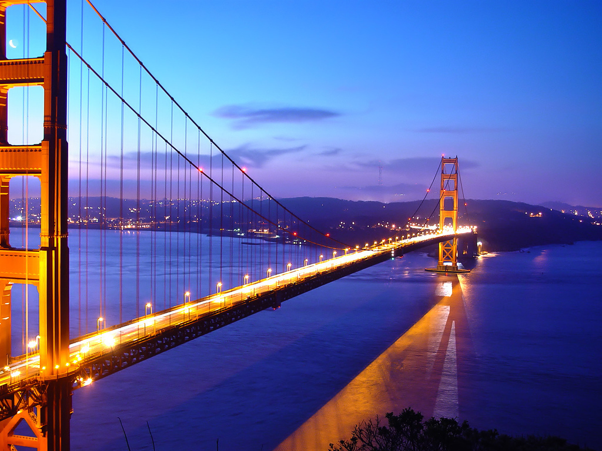

Arch bridge Niagara Falls
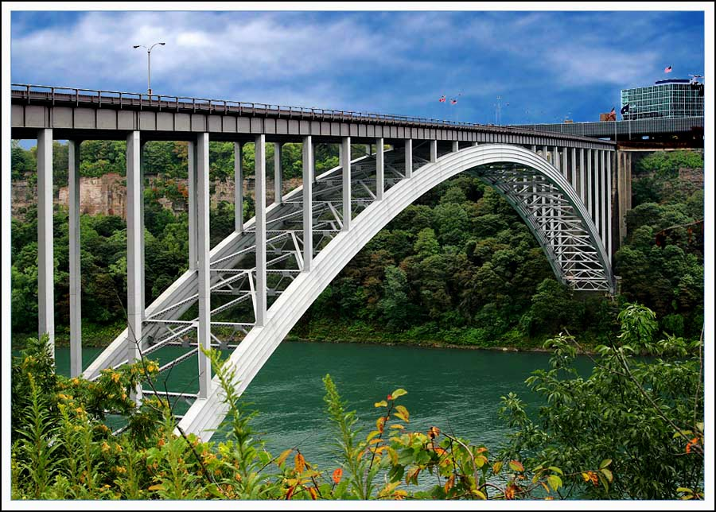
http://michaelweinberg.com/commercial_photos/bridge_canada.jpg

Queens middle town tunnel NY
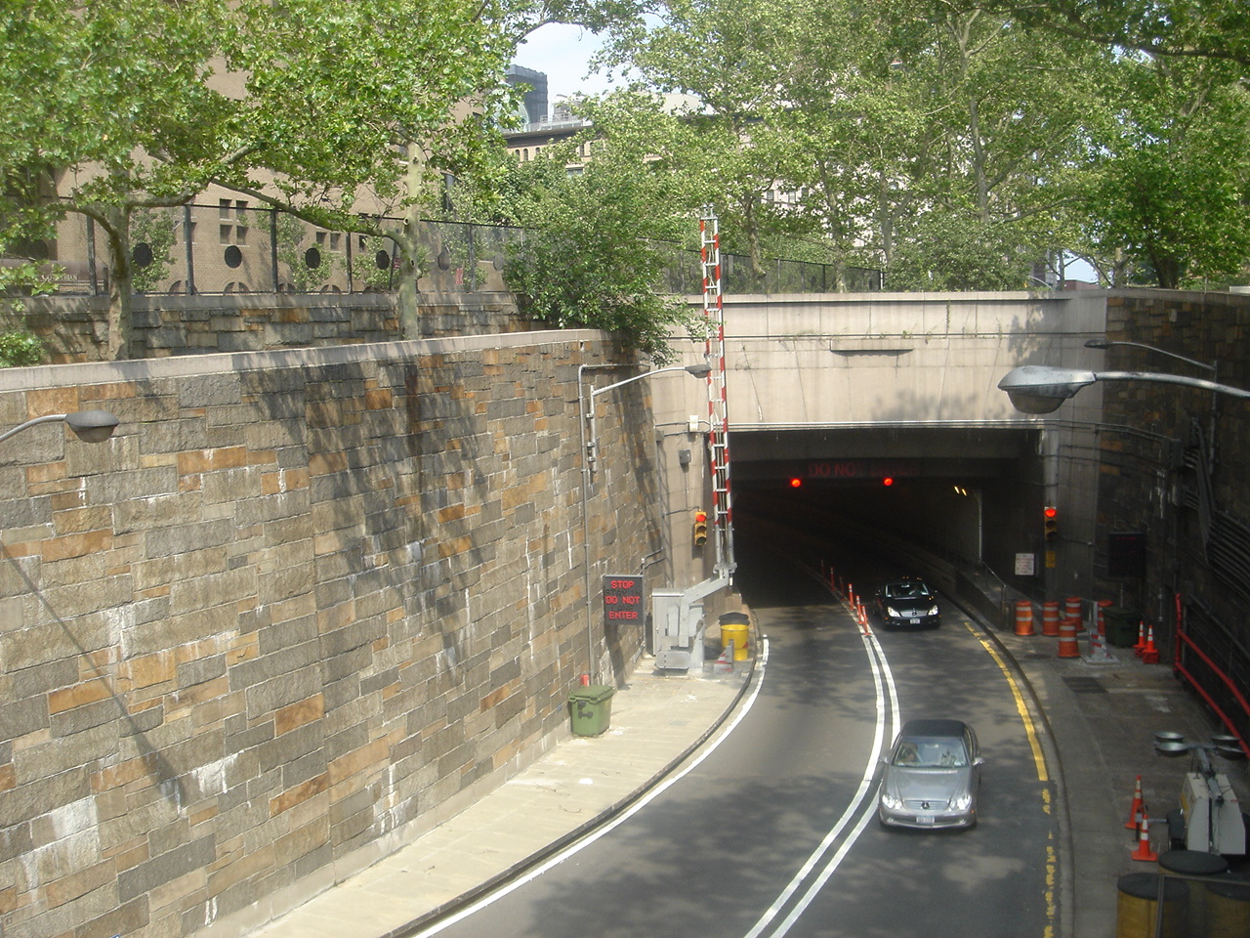http://upload.wikimedia.org/wikipedia/commons/8/8c/Queens-Midtown_Tunnel_4.JPG

Lincoln tunnel
Manhattan NY
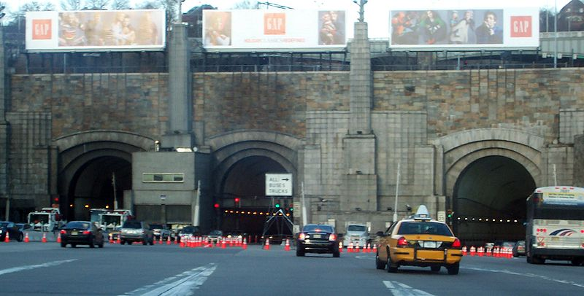
http://en.wikipedia.org/wiki/File:Lincolntunnel.jpg
Dark gate tunnel, Esztergom, hungry
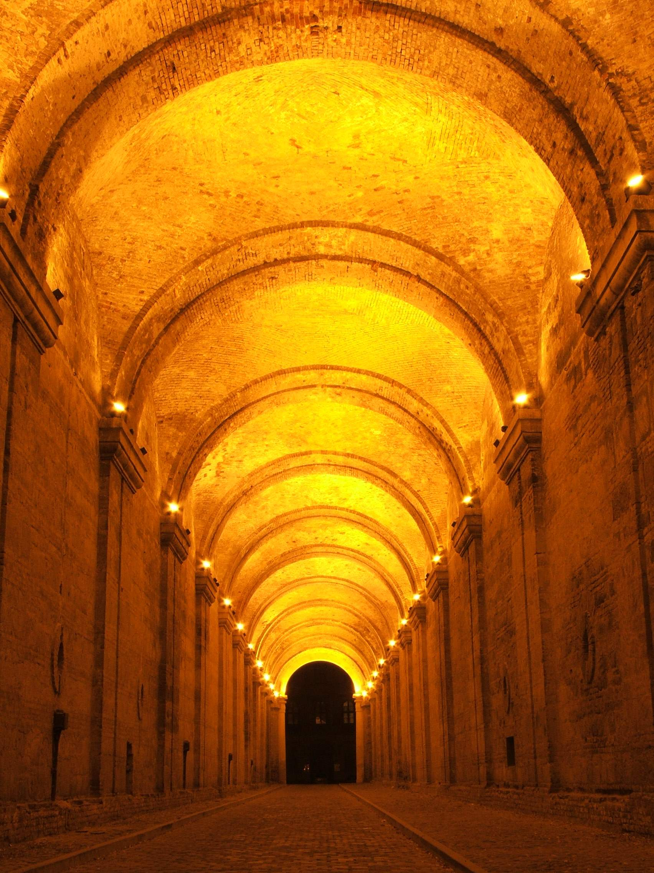
http://upload.wikimedia.org/wikipedia/commons/c/cc/Sotetkapu.JPG

